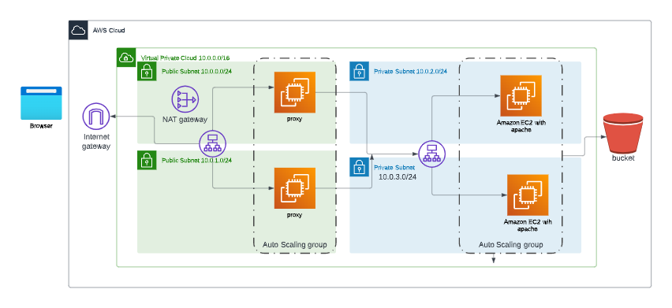
Lab 4
Implement a vpc with cidr 10.0.0.0/16 with 2 public subnets with cidrs 10.0.0.0/24 and 10.0.0.2.0/24 with a load balancer to Distribute the traffic between 2 machines with nginx installed in them as a proxy and 2 private subnets with the below cidrs 10.0.1.0/24 and 10.0.0.3.0/24 then a 2 instances attached in autoscaling in the private subnets with apache installed without SSH and load balancer to install between them and the ec2 will get the app
from an s3
Needed :
- A screenshot from the autoscaling group after indicating the minimum ,maximum and desired instances
- Screenshot from the 2 target groups indicating the machines are healthy
- Screenshot indicate the the machines BE WS are private
- Screenshot from the public load balancer when you hit a request from it from a browser with a response returned from the instances
- Screenshot from the userdata
- Screenshot from s3 to be private

- A screenshot from the autoscaling group after indicating the minimum ,maximum and desired instances
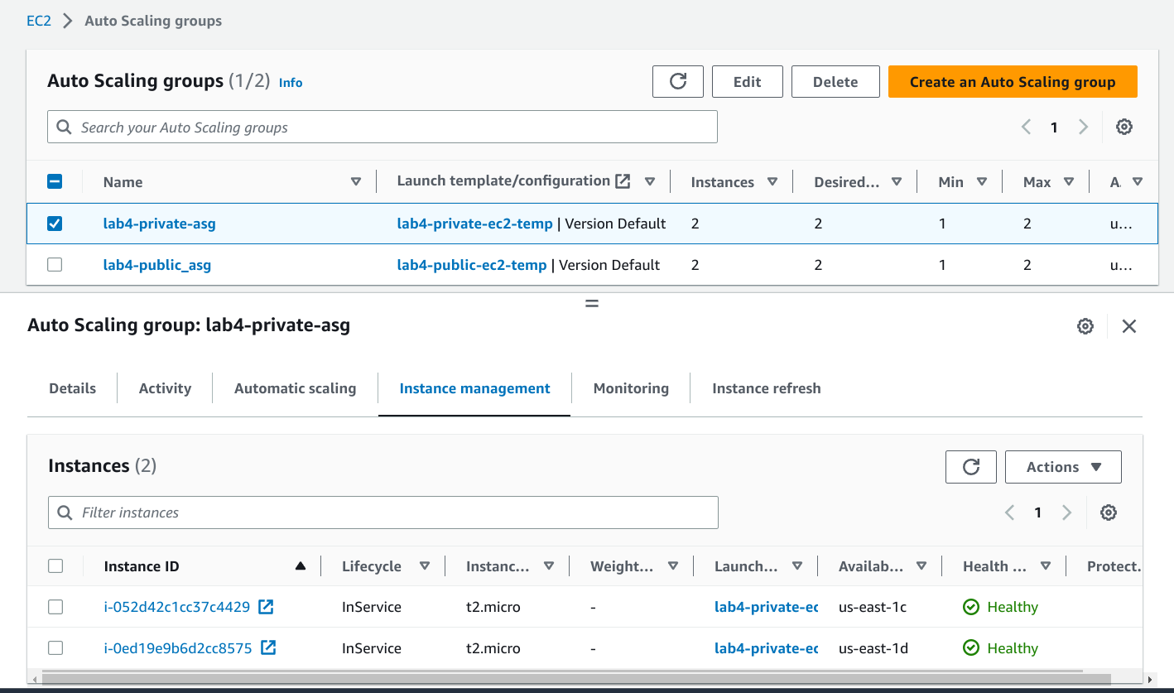
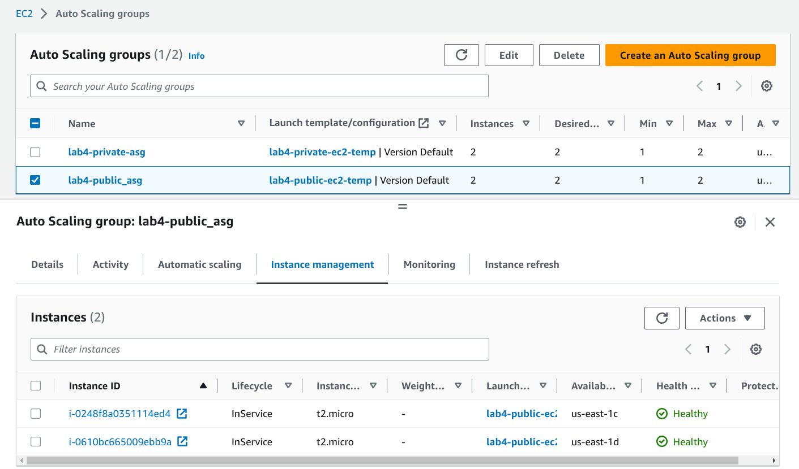

- Screenshot from the 2 target groups indicating the machines are healthy
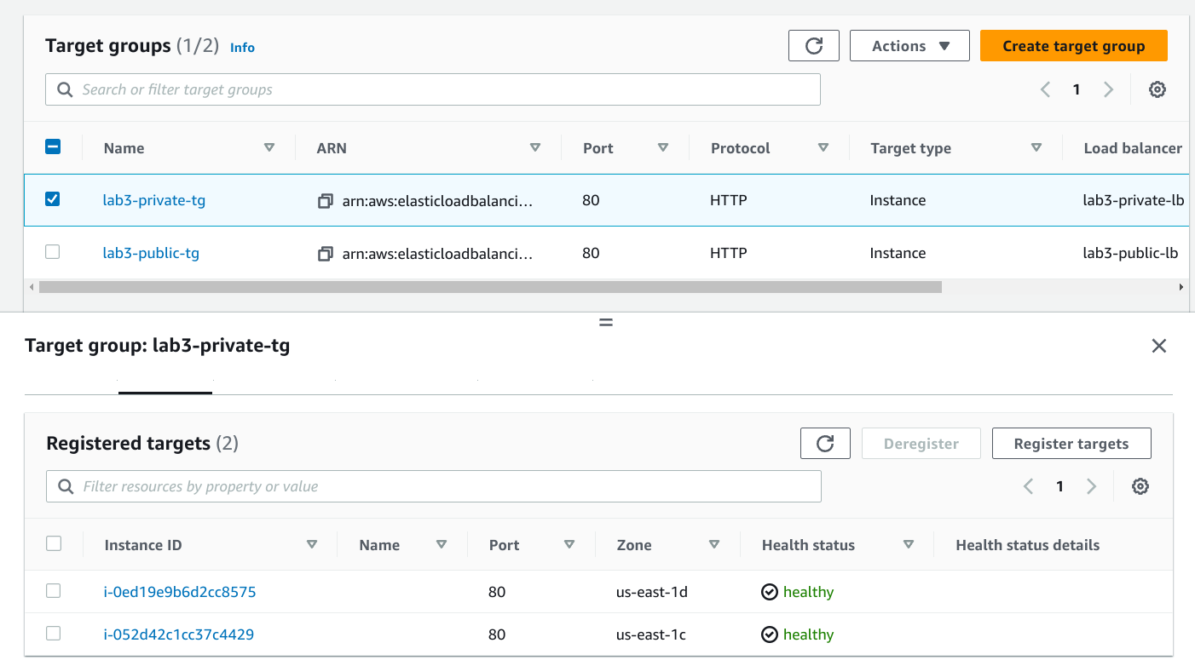
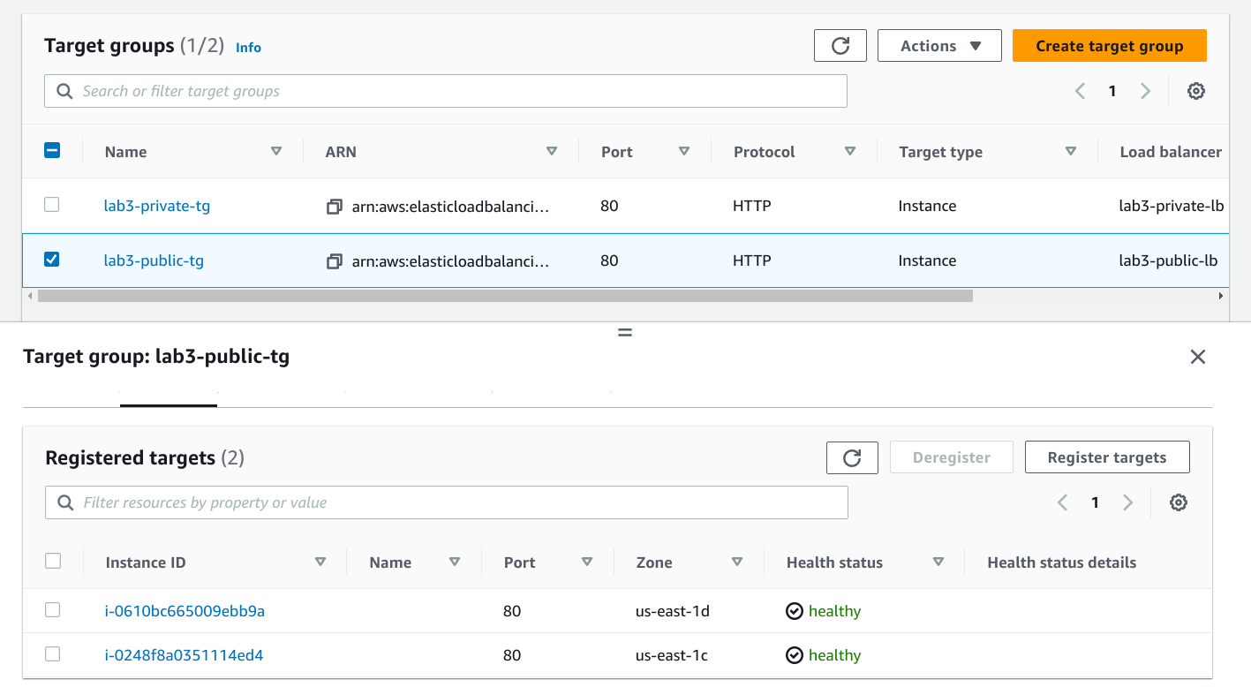

- Screenshot indicate the the machines BE WS are private
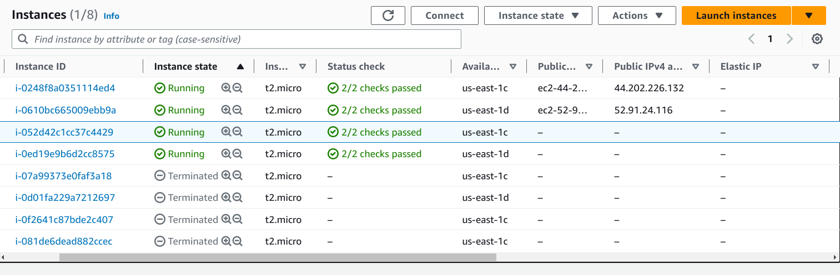
as the screenshot informs, the two instances whose ids ends with “29” and “75”, which are in the private target group and in the private auto scale group as implied by the previous screenshot, those two instances have no public IP.s

- Screenshot from the public load balancer when you hit a request from it from a browser with a response returned from the instances
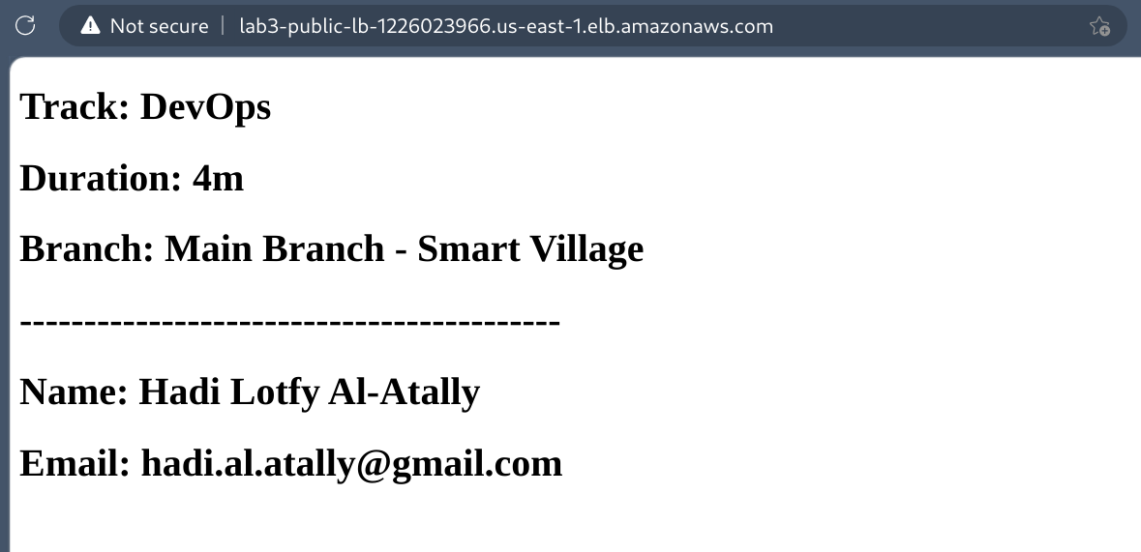

- Screenshot from the userdata
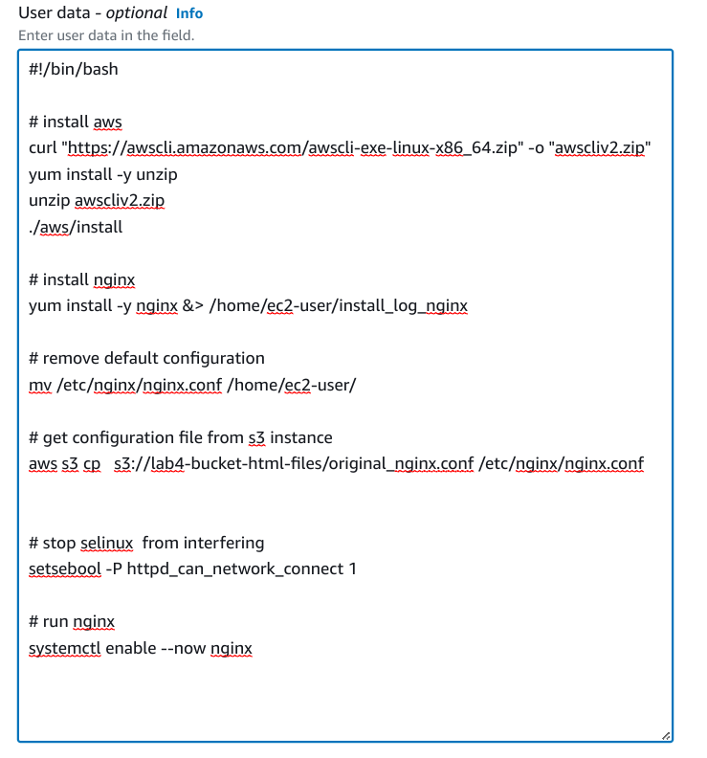
user date section in the public-instance Launch Template.

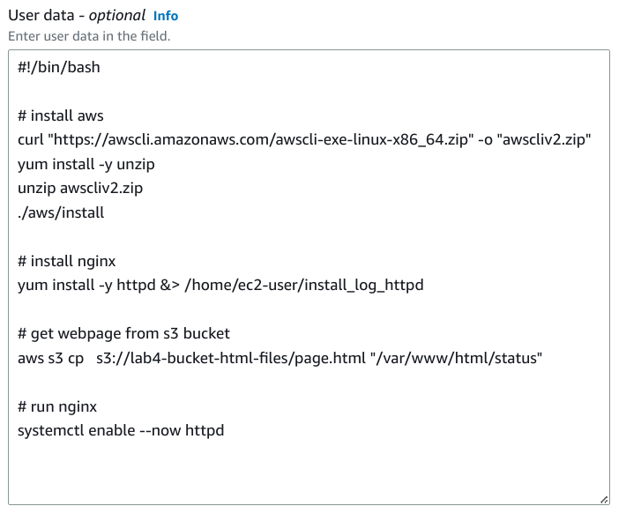
user date section in the private-instance Launch Template.

- Screenshot from s3 to be private
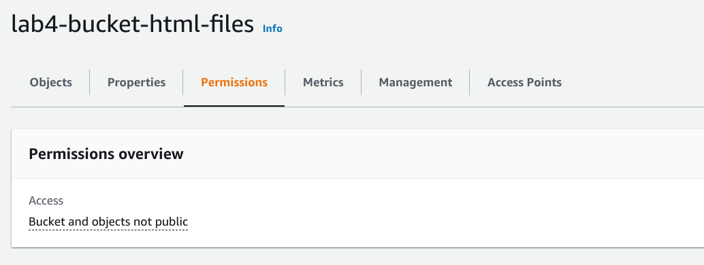

- Additional screenshots:

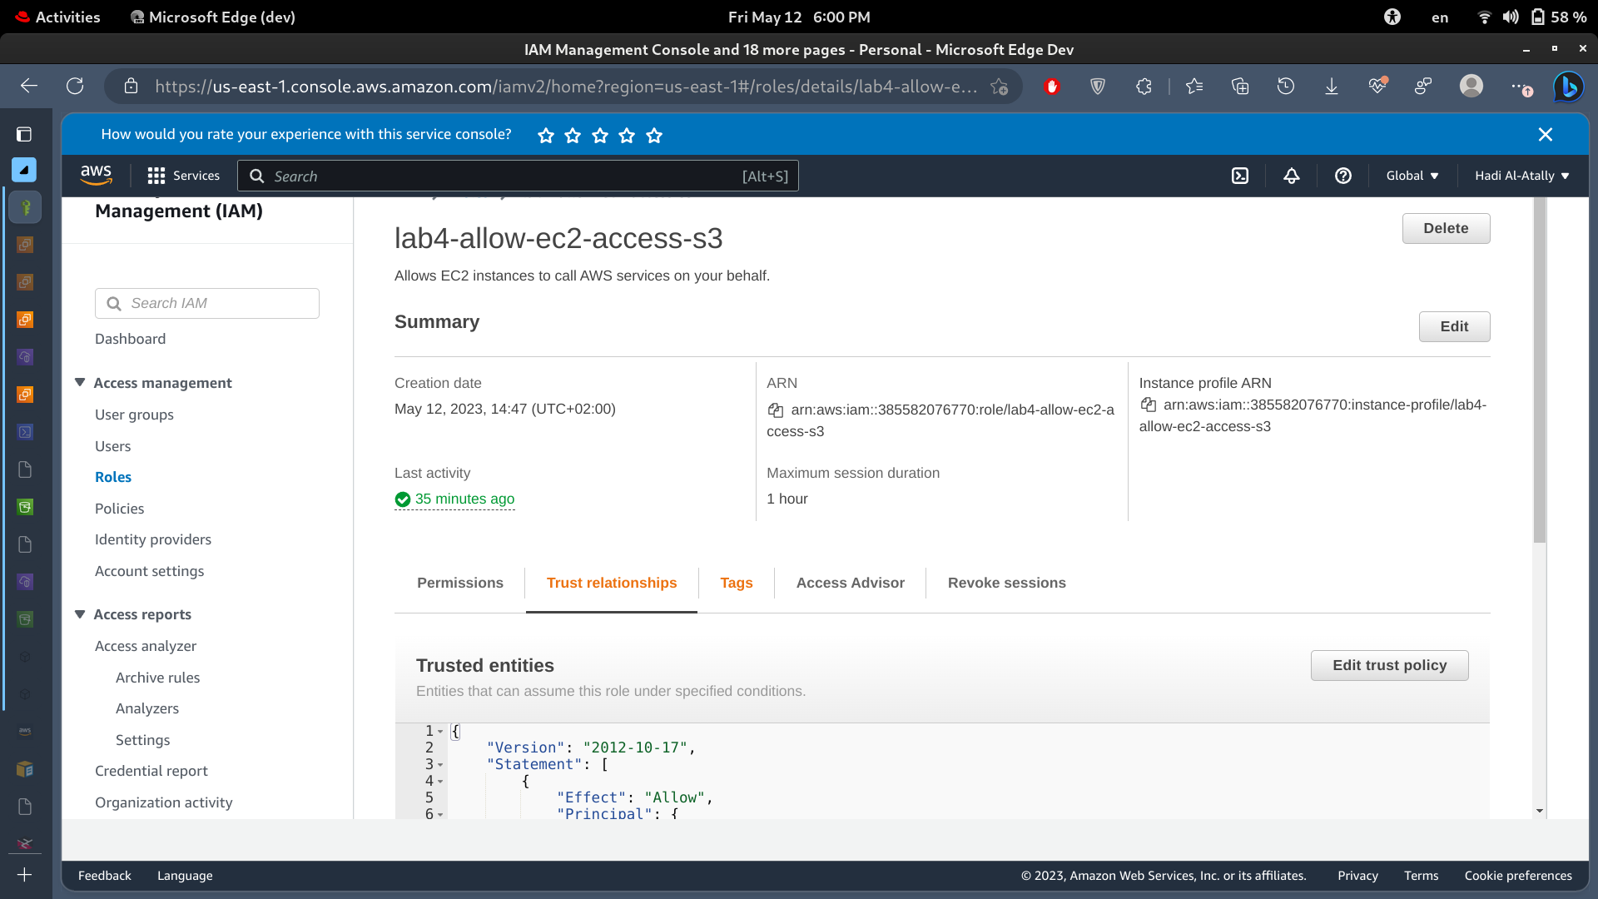
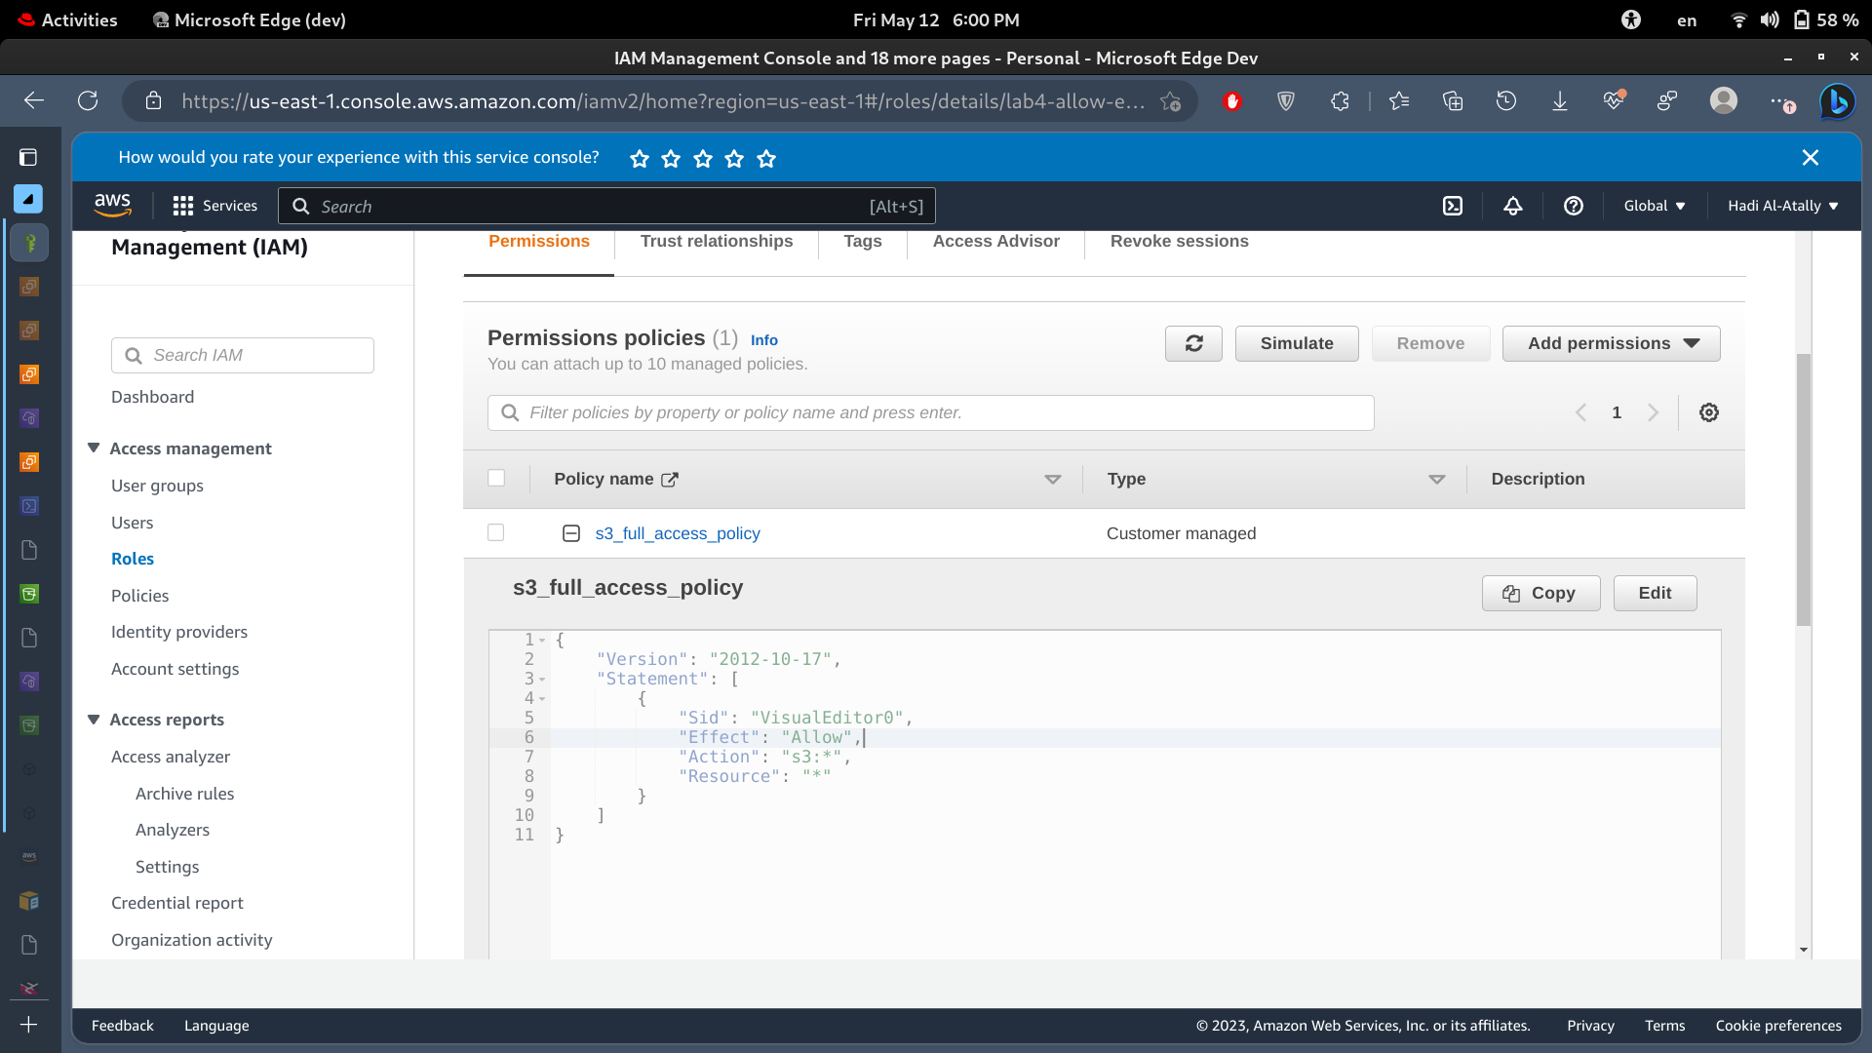

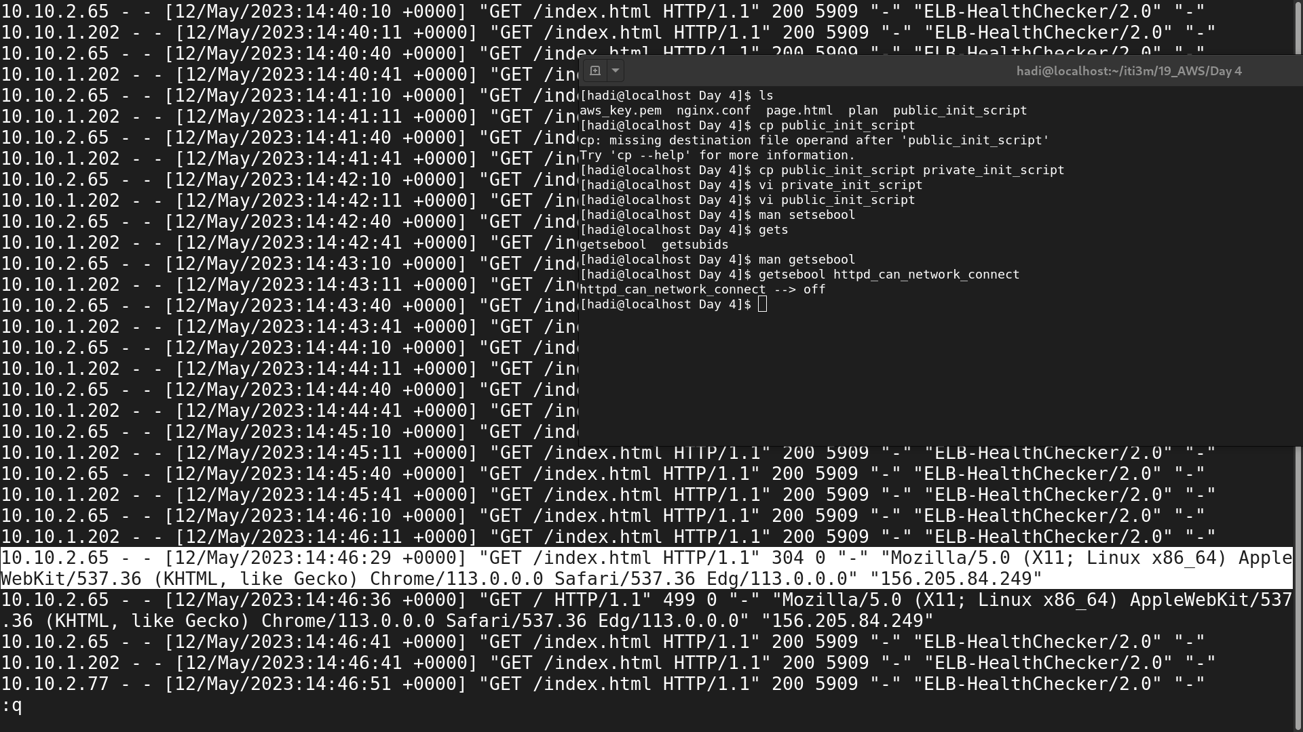
while doing some troubleshooting this screenshot was taken for the access.log file for ngin in one of the public instances,
It shows the continuous health checking which of course comes from the auto scale group and the target group.
And it shows some http Get requests from the end user ip (the selected lines)

